The Sixth Weissenburg Symposium
September 02 - 05, 2020
Venue: Kulturzentrum Karmeliterkirche, Weissenburg in Bayern, Germany

“Genome-wide Epigenetic Profiles”

Dear friends of the Weissenburg Symposia,

The Weissenburg Symposia have a tradition which dates back to the International Cologne Spring Meeting of 1981 on
“DNA Methylation and Gene Activity”,
the first of its kind and to five Weissenburg Symposia between 2001and 2014. Here is a list of previous symposia which have attracted leading researchers in this fast growing field:
Cologne Spring Meeting 1981 - DNA Methylation and Gene Activity.
First Weissenburg Symposium 2001 - Medicine and Molecular Biology. May 03 – 06, 2001.
Second Weissenburg Symposium 2004 - DNA Methylation - an Important Genetic Signal. Significance in Biology and Pathogenesis. May 12 – 15, 2004.
Third Weissenburg Symposium 2007 - Medicine at the Interface between Science and Ethics. May 30 – June 01, 2007.
Fourth Weissenburg Symposium 2011 - Epigenetics and the Regulation of Gene Expression. June 20 – 22, 2011.
Fifth Weissenburg Symposium 2014 - Epigenetics – a Different Way of Looking at Genetics. September 14 – 17, 2014.

Secured Financial Support for the Symposium
Funding for the Sixth Weissenburg Symposium, September 2020 has been secured through Leopoldina - National Academy of Sciences in Halle/Saale; the Fritz-Thyssen-Foundation in Köln, the German Cancer Research Center in Heidelberg, and likely the Hermann Gutmann Stiftung in Weissenburg/Nürnberg.

Hence, it is my pleasure to invite you to attend the next symposium in Weissenburg which, like its predecessors, is an open meeting. Helli and I will be delighted to welcome you in Weissenburg next September.

List of Confirmed Speakers and Preliminary Lecture Titles as of December 2019

Asifa Akhtar, MPI Freiburg - akhtar@ie-freiburg.mpg.de
Developmental dynamics of histone H4 lysine 16 acetylation.
*Stefan Beck, University College London - s.beck@ucl.ac.uk
Methylome analysis: from profiles to function.
Thomas R. Broker, University of Alabama, Birmingham – broker@uab.edu
Clonal selection for a single locus of transcriptionally active HPV oncogenes in cancers involving DNA methylation-mediated silencing.
*Howard Cedar, Hebrew University, Jerusalem - cedar@mail.huji.ac.il Title pending
Louise T. Chow, University of Alabama, Birmingham – ltchow@uab.edu
Histone deacetylase inhibitors abrogate HPV DNA replicative amplification.
*Melanie Ehrlich, Tulane University Louisiana, New Orleans - ehrlich@tulane.edu
Epigenetic insights into common human diseases.
*Armin Ensser, Friedrich-Alexander University Erlangen - armin.ensser@fau.de
Gamma-herpesviral tegument proteins - proviral manipulators of ND10- and SMC-protein related nuclear processes.
*Ingemar Ernberg, Karolinska Institutet, Stockholm - Ingemar.Ernberg@ki.se
The role of epigenetics in the control of Epstein-Barr viral latent infection and oncogenesis.
*Manel Esteller, Josep Carreras Leukaemia Research Institute, Badalona, Barcelona, Catalonia - mesteller@carrerasresearch.org
Epigenetics and epi-transcriptomics of human cancer: From knowledge to applications.
*Andy Feinberg, Johns Hopkins University - afeinberg@jhu.edu
Cancer is a disease of epigenetic stochasticity.
*François Fuks, Université Libre de Bruxelles – ffuks@ulb.ac.be
Role of RNA Modifications in Health and Disease.
*Anita Göndör and Rolf Ohlsson, Karolinska Institutet, Stockholm – rolf.ohlsson@ki.se
WNT signaling and AHCTF1 promote oncogenic MYC expression through super-enhancer-mediated gene gating
*Bernhard Horsthemke, Universität Duisburg-Essen - bernhard.horsthemke@uk-essen.de
The sperm methylome of fertile, infertile and aging men..
*Rudolf Jaenisch, MIT - jaenisch@wi.mit.edu
Epigenetic regulation in development, aging and disease.
*Albert Jeltsch, Universität Stuttgart - albert.jeltsch@ibtb.uni-stuttgart.de Travel by car.
Novel insights into the mechanism of DNA Methyltransferases by Deep Enzymology studies.

*Peter Jones, Van Andel Research Institute, Grand Rapids, MI - peter.jones@vai.org
How DNA gets methylated.
David M. Knipe, Harvard Medical School - david_knipe@hms.harvard.edu
Epigenetic battles between DNA viruses and their host cells.
*Heinrich Leonhardt, LMU München - h.leonhardt@lmu.de
Role and regulation of DNA modifications in development and disease.
Stefan Mundlos, Charité Berlin - stefan.mundlos@charite.de Title pending
*Art Petronis, University of Toronto, Toronto, Canada – art.petronis@camh.ca
Chronoepigenomics.
*Christoph Plass, DKFZ, Heidelberg - c.plass@dkfz.de
Acute myeloid leukemia with deletion on chromosome 7q.
Anjana Rao - La Jolla, California - anrao@ucsd.edu
TET methylcytosine oxidases, cell lineage specification, immune responses and cancer.
*Wolf Reik, Babraham Institute, Cambridge, UK - wolf.reik@babraham.ac.uk
Single cell epigenome landscape of development and ageing.
Karsten Rippe, DKFZ, Heidelberg - Karsten.Rippe@bioquant.uni-heidelberg.de
Linking chromatin states and interferon induced gene expression.
*Michal-Ruth Schweiger, University of Cologne – mschweig@uni-koeln.de
Peri-centromeres and their role in chemotherapy resistance.
Yang Shi, Harvard - yang_shi@hms.harvard.edu
Manipulating epigenetic regulators to enable immune checkpoint blockage.
Daniel Summerer, TU Dortmund - daniel.summerer@tu-dortmund.de
Designer receptors and reagents for chromatin chemical biology.
*Moshe Szyf, McGill University, Montreal - moshe.szyf@mcgill.ca
Early life stress, trauma and post trauma stress disorder: Is there a role for DNA methylation?
Jussi Taipale, Karolinska Institutet, Stockholm - jussi.taipale@ki.se Title pending
Alexander Tarakhovsky, Rockefeller University, New York, NY - tarakho@rockefeller.edu
Epigenetic mimicry by viruses.
*Aslı Tolun, Istanbul Technical University, Istanbul. tolunasli@itu.edu.tr
Lessons learned from disease gene search.
*Toshikazu Ushijima, National Cancer Center, Tokyo - tushijim@ncc.go.jp
Impact of epigenetic alterations in epithelial and stromal cells induced by chronic inflammation on cancer risk and treatment.
*Jörg Tost, CEA-Institut de Biologie François Jacob, Evry, France - tost@cng.fr
Epigenetic changes in immune-related diseases and their use for personalized patient management.
Miklos Toth, Weill Cornell Medical College, New York, NY - mtoth@med.cornell.edu Epigenetically bi-stable genomic elements in the brain govern neuronal (mal)-adaptation to changing environments.
*Jörn Walter, Saarland University, Saarbrücken - j.walter@mx.uni-saarland.de
Modeling of genome wide DNA-methylation dynamics.

Xiaoliang Sunney Xie, Beijing University – sunneyxie@pku.edu.cn
Decoding the human functional genome.

The names of speakers marked by an asterisk * have attended previous Weissenburg Symposia.

Lectures will commence on Wednesday, September 02, 2020 at 9:00 o’clock AM. The symposium will close on Saturday, September 05 at around noon.
Travel to Weissenburg:
By car – Autobahn A6 direction Nürnberg, exit 52 Ansbach to B13, direction Augsburg, Weißenburg.
By train – Local trains (RE, Regional Express) from Nürnberg Hauptbahnhof direction Augsburg or München, usually platform 5 (recheck) every 08 and 39 minutes past the hour.
By plane: Closest airport Nürnberg (Albrecht-Dürer, about 70 km) or München (Franz-Josef-Strauss, about 100 km), from there by train, rental car or taxi.
Please reserve your own accommodations under https://www.weissenburg.de/unterkunft/
We are very much looking forward to welcoming you to the Sixth Weissenburg Symposium. For questions, contact me at walter.doerfler@t-online.de or at mobile phone +49-171-205-1587.
Best wishes,
Walter Doerfler
Co-organizers are Prof. Dr. Dr. Ruth-Michal Schweiger, University of Cologne and
Prof. Dr. Christof Plass, German Cancer Research Institute, Heidelberg
Impressions of the Medieval Town

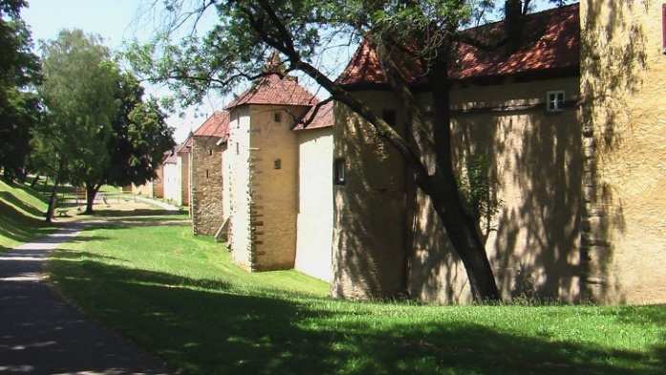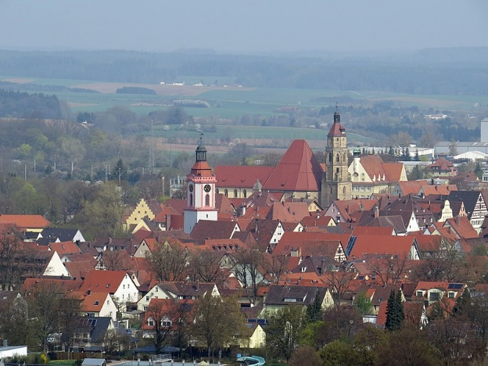
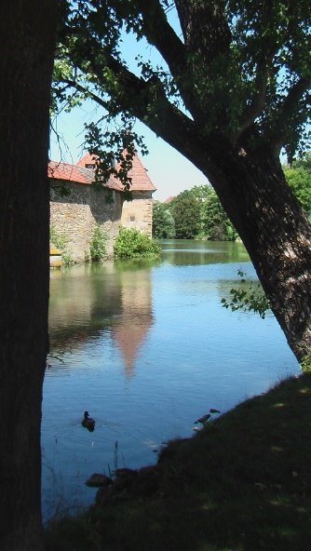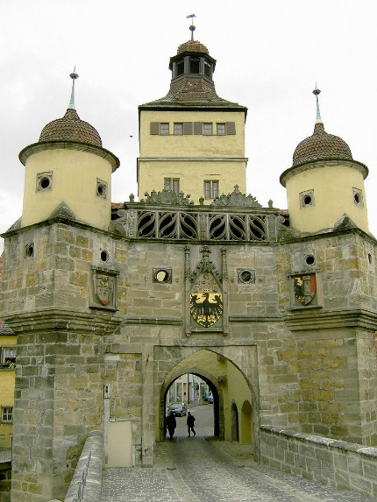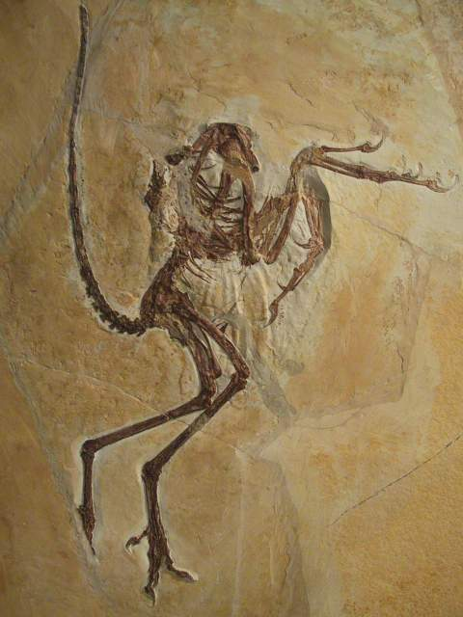
Weissenburg is a town in Northern Bavaria (Frankonia) of about 18,500 inhabitants located 130 km to the North of Munich and 60 km to the South of Nuremberg. Its origins date back to a Castrum Romanum (fortification) and vicus (settlement) from around 90 CE when the Roman Empire was extended North beyond the river Danube under Roman emperors Domitian (81-96 CE) and Trajan (98-117). Artifacts from the Roman time, particularly a spectacular treasure discovery in 1979, are on display in a Roman Museum, located almost next door to the meeting venue. Today’s town lies close to the remnants of the Roman Limes, which has been granted the status of world cultural heritage. The present town has a medieval core which survived WWII unscathed and goes back to a royal court (867 CE) and the city rights of 1186. In 1530, city officials co-signed the Augsburg Convention. Between 1588 and 1611, Weissenburg’s neighbor, the margrave of Ansbach-Hohenzollern, erected a huge fortification, the Wülzburg which, at different times, housed prisoners or internees of wars (Charles de Gaulle WWI or the composer Erwin Schulhoff WWII), refugees from the East after WWII or most recently from the Middle East. Together with all of Frankonia, Weissenburg became part of Bavaria in 1806. Today Weissenburg is county seat and harbors miscellaneous enterprises – wire and wire products, automobile accessories, plastic parts for various industries, hydroelectric turbines, Schwan-Stabilo pens and cosmetics, nearby Solnhofen lime stone industry etc. The Bürgermeister Müller museum in Solnhofen (15 km distance from Weissenburg) offers a highly impressive collection of specimens from the prehistoric Jurassic period (150 million years ago), among them an Archaeopteryx of which the first specimen ever was discovered in Solnhofen in 1861 (see below). Additional close-by places of interest are the Frankonian Lake District; baroque town Ellingen (4km; Seat of the Teutonic Knights through 1806); Bishop seat and Catholic University Eichstätt (24 km); Fossa Carolina (10km; Charlemagne’s attempt around 800 CE to link the Rhine and Danube rivers by a canal).

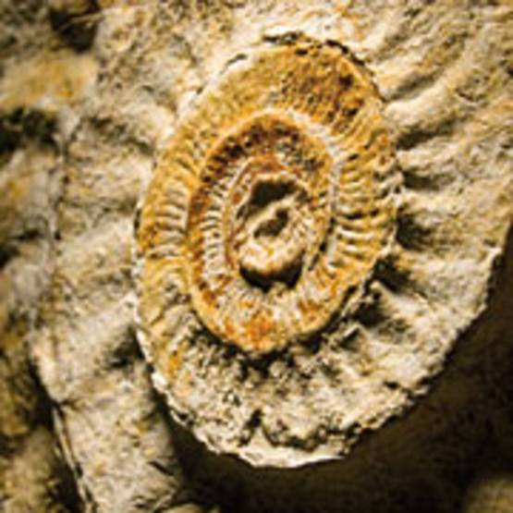
Archaeopteryx Ammonite

